**Responsive Starbucks Website Design Using HTML CSS And JavaScript**

**Leyan Burait**

**Email:**[**lyanbyrat53@gmail.com**](mailto:lyanbyrat53@gmail.com)

[**layanbuirat(LeyanBuirat)(github.com)**](https://github.com/layanbuirat)

**objects:**

# File of Style.css

1. **\* { ... }**:

This is a universal selector that applies the defined styles to all elements on the page.

1. **padding: 0;**:

This removes any default padding from all elements. Padding is the space between an element's content and its border.

1. **margin: 0;**:

This removes any default margin from all elements. Margin is the space outside the border of an element, creating space between elements.

1. **box-sizing: border-box;**:

This changes the box model used for elements. With border-box, the width and height of an element include its padding and border, making layout calculations more intuitive. This means if you set an element to be 100px wide, the padding and border are included within that 100px.

1. **scroll-padding-top: 2rem;**:

This adds padding to the top of the viewport when scrolling to an anchor link or target element, ensuring that there’s some space above the element. The 2rem value is relative to the root element's font size, providing a consistent spacing.

1. **text-decoration: none;**:

This removes any text decorations like underlines from all text elements. This is often used to style links (<a> elements) so that they don’t have the default underline.

1. **list-style: none;**:

This removes default list item markers (bullets or numbers) from unordered (<ul>) and ordered lists (<ol>).

1. **scroll-behavior: smooth;**:

This makes scrolling behavior smooth for anchor links and other scroll actions. Instead of jumping instantly to the target, the page will scroll smoothly.

1. **font-family: "Poppins", sans-serif;**:

This sets the default font for all text on the page. "Poppins" is a specific font (if available), and if it’s not available, the browser will use a generic sans-serif font instead.

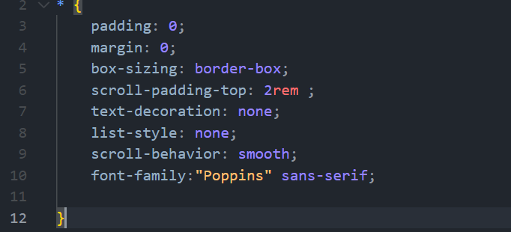

From : [Selection Embed Code - Google Fonts](https://fonts.google.com/selection/embed) get all font style you need it

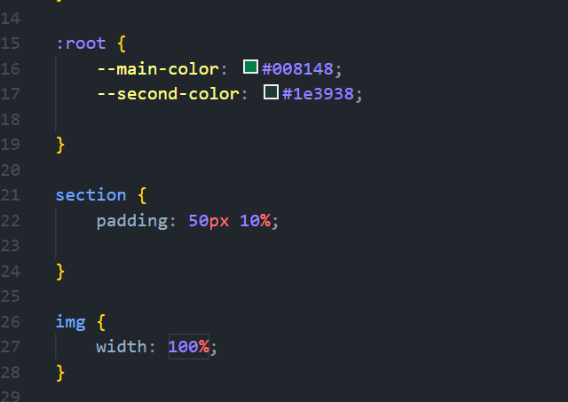

# Header property

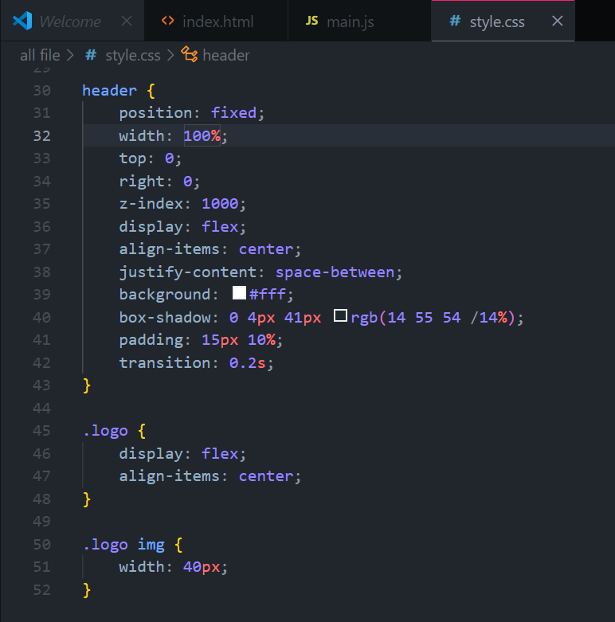

In html

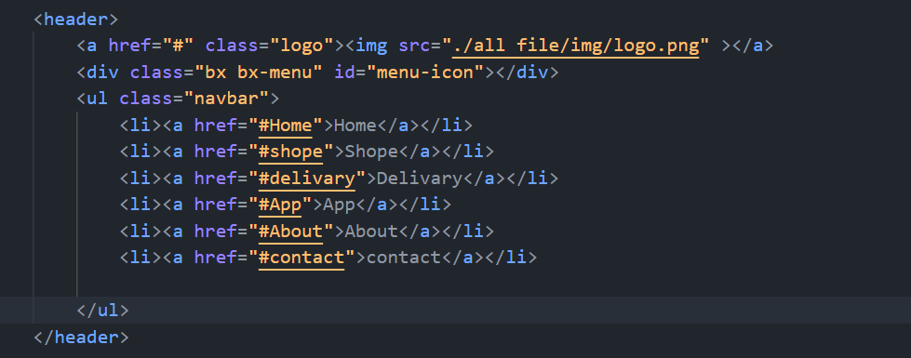

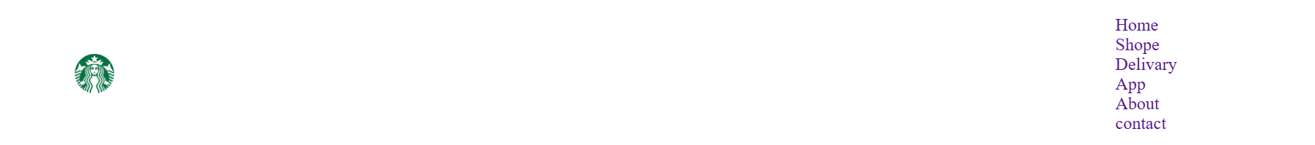

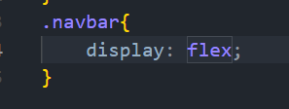



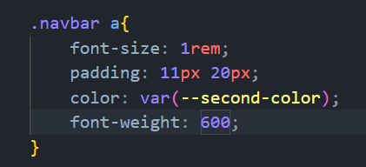



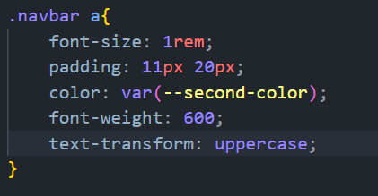

Figure 1 text-transform: uppercase;



# <i class="fa-solid fa-bars menue"></i> : icon



Figure 2<i class="fa-solid fa-bars menue"></i>

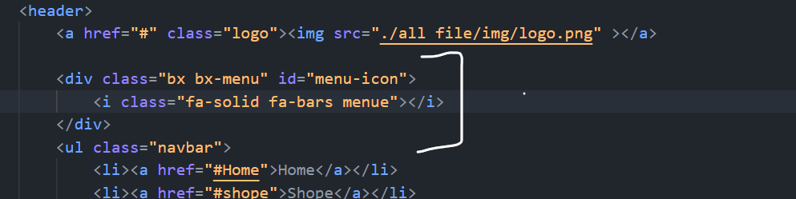



# Home

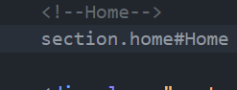

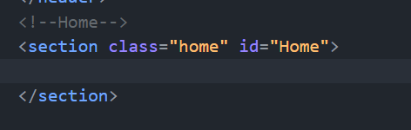

# Add *:: selection{}

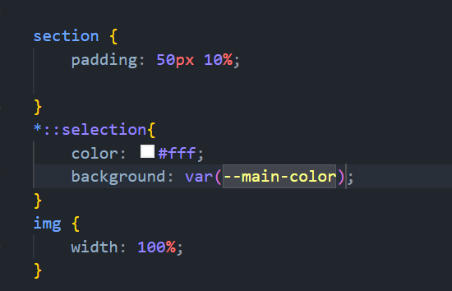

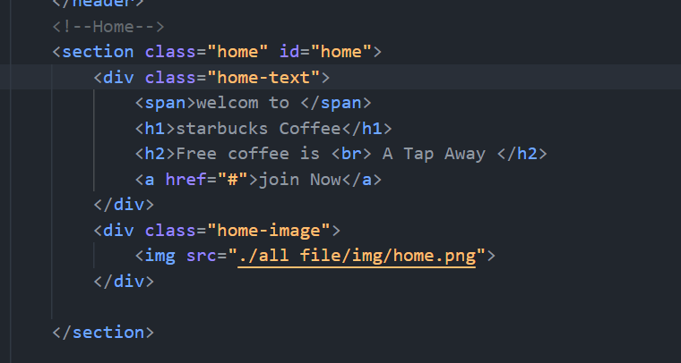

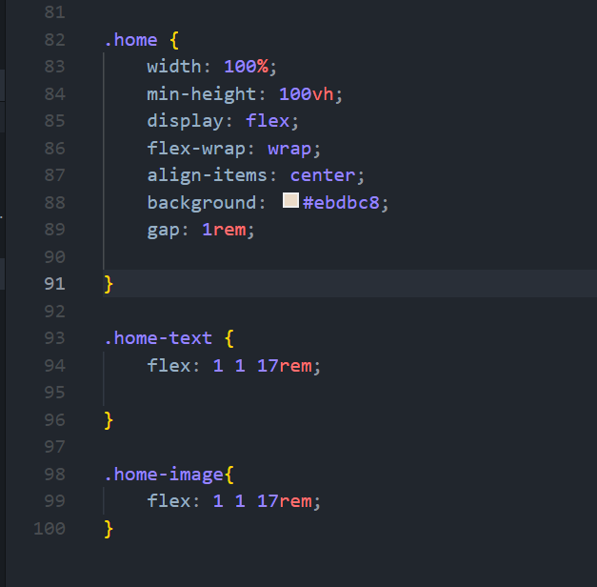

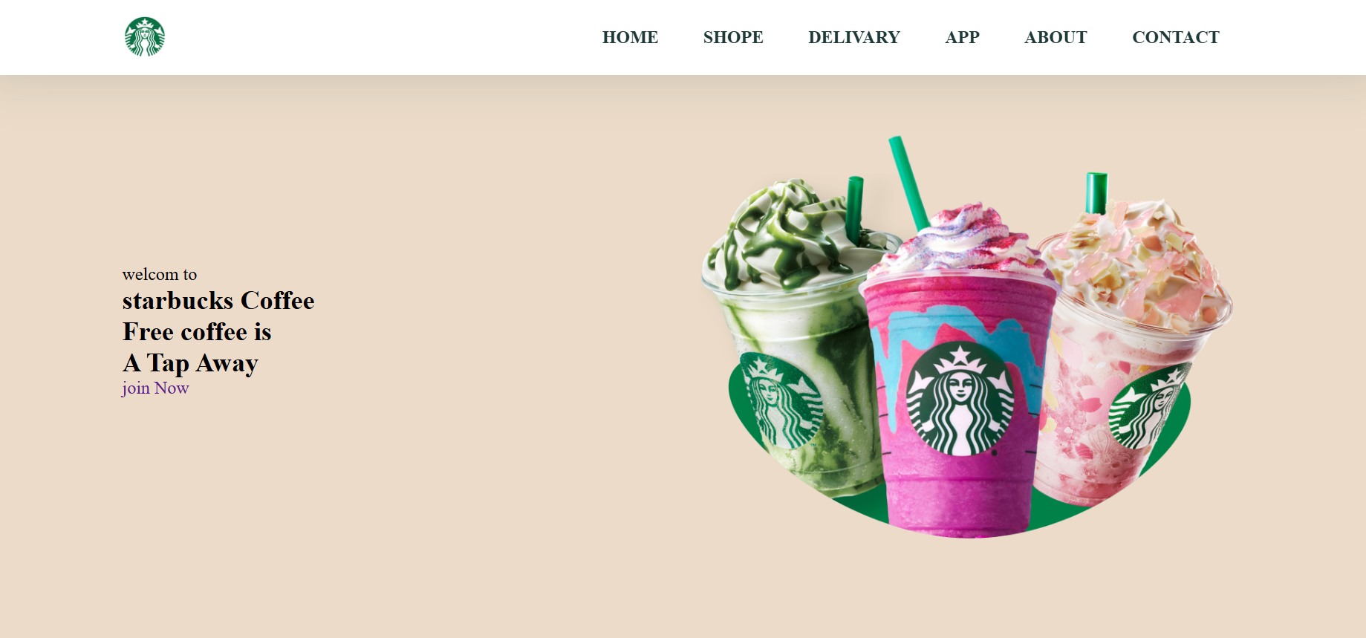

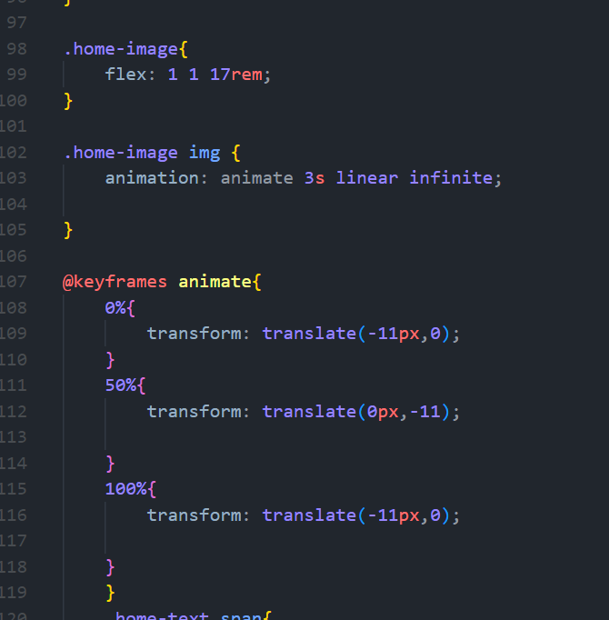

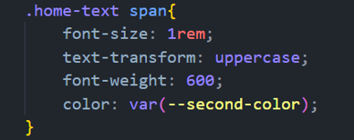

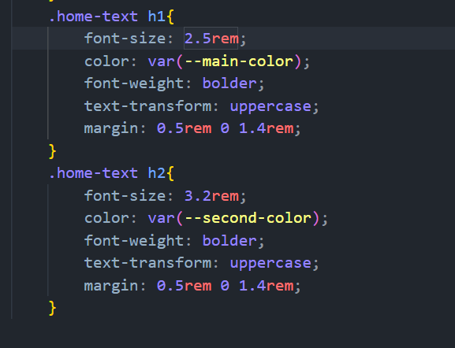

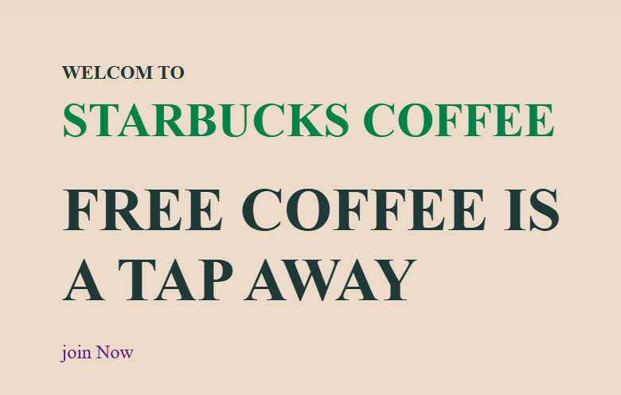

# Button of join now

                <a href="#" class="join">join Now</a>

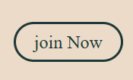

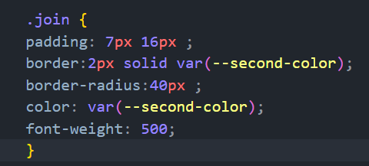

# Button hover

When put mouse of button then the color of font change to weight & the background will become as secont color

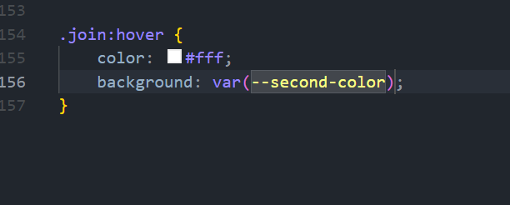

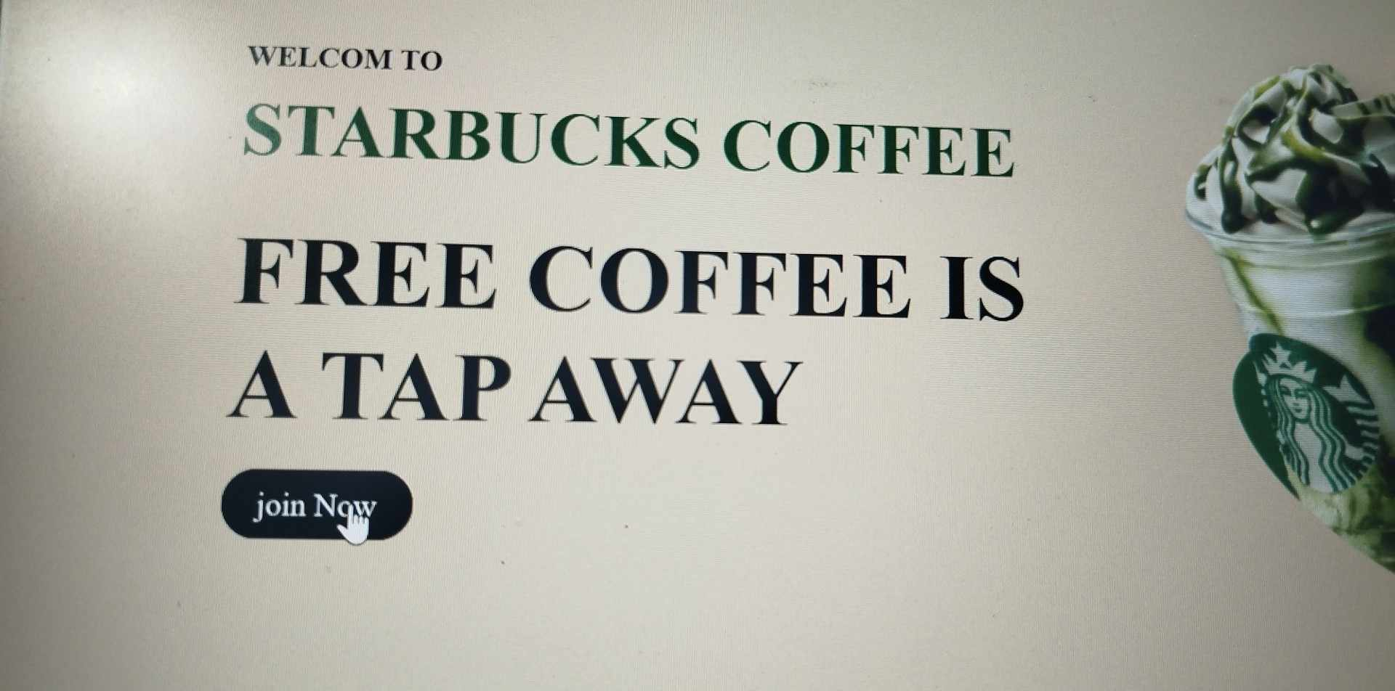

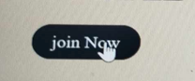

Figure 3join:hover{}

# **Div of shop**

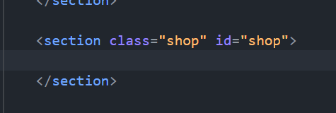

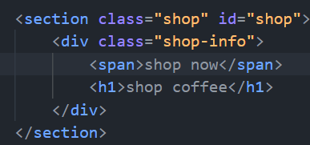

# Of shop-info     text-align: center;

To put the all item in shop-info in ceter page as show bellow

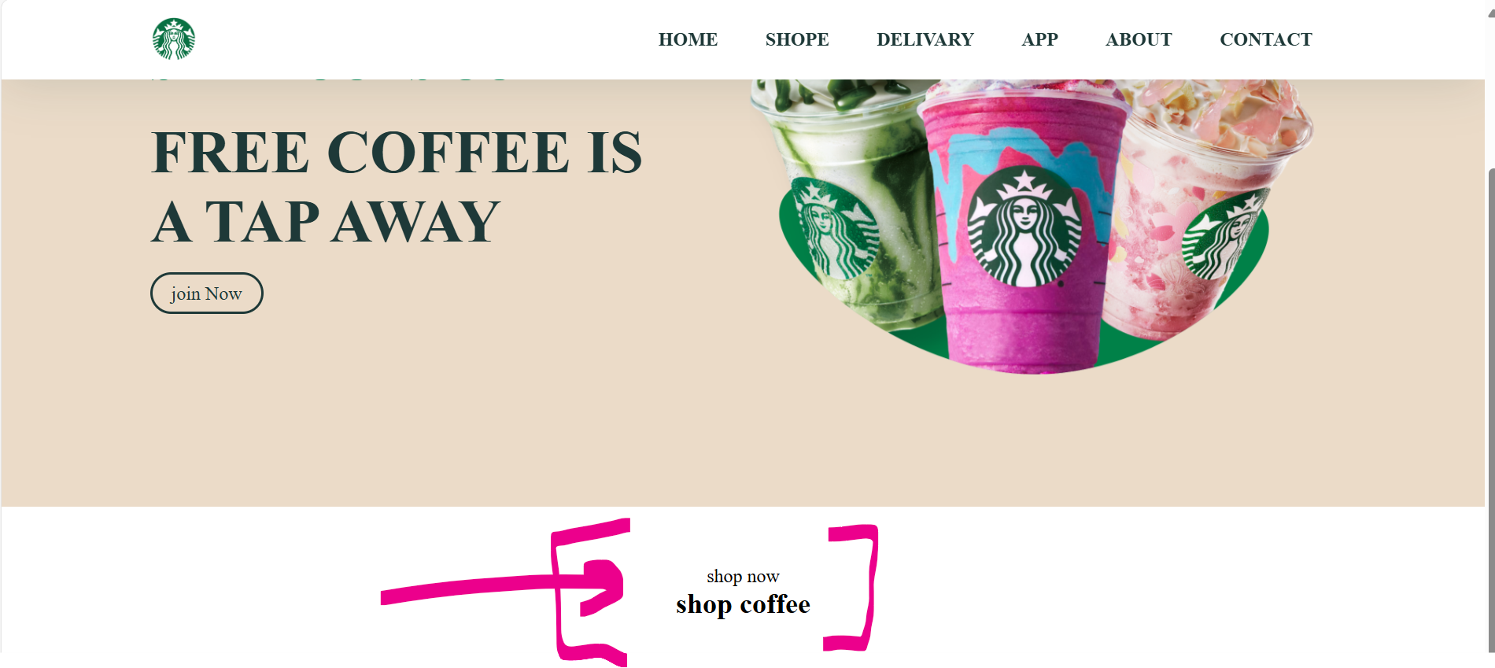

# Shop-info span

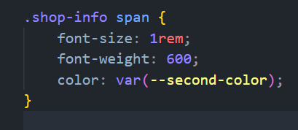

# Shop-info h1

# 

# 

# use text-transform:uppercase;

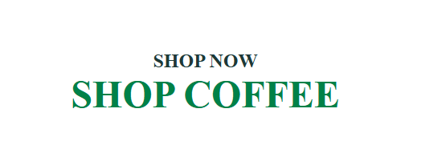

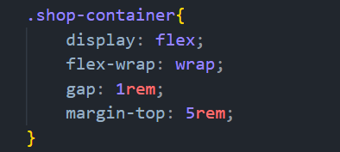

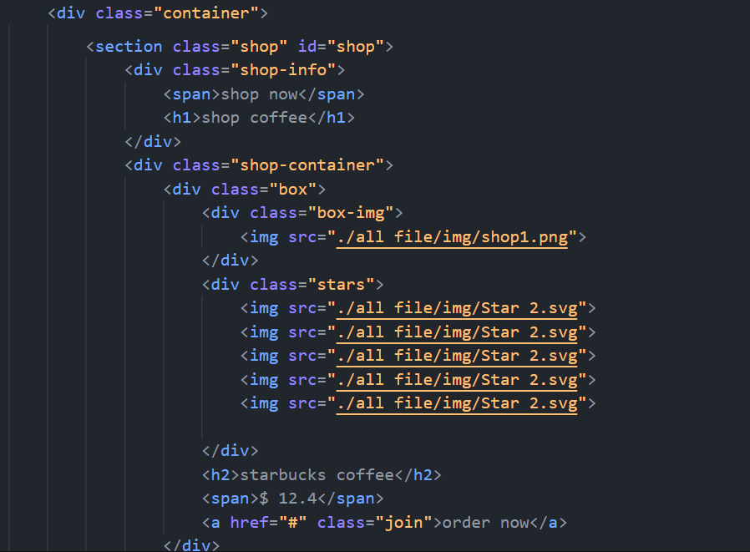

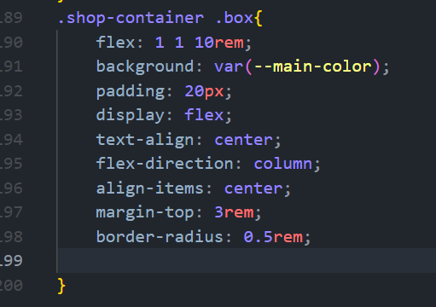

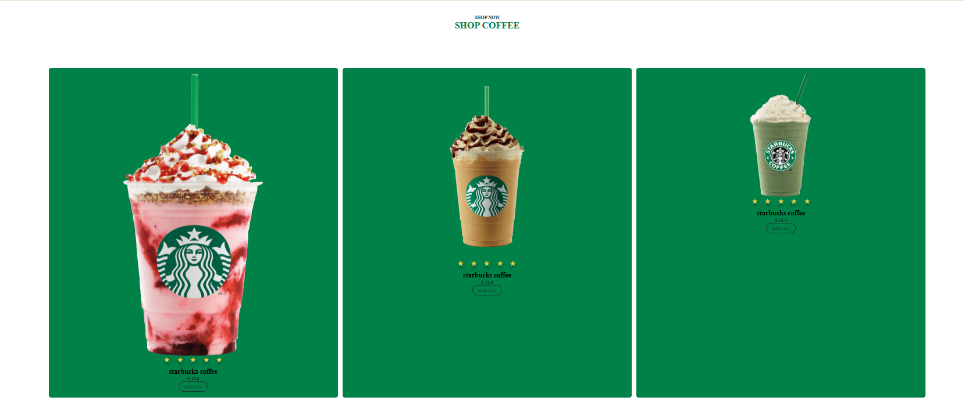

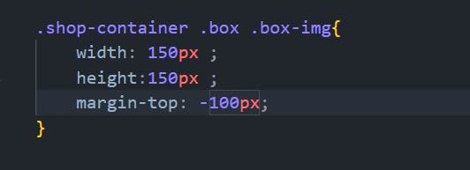

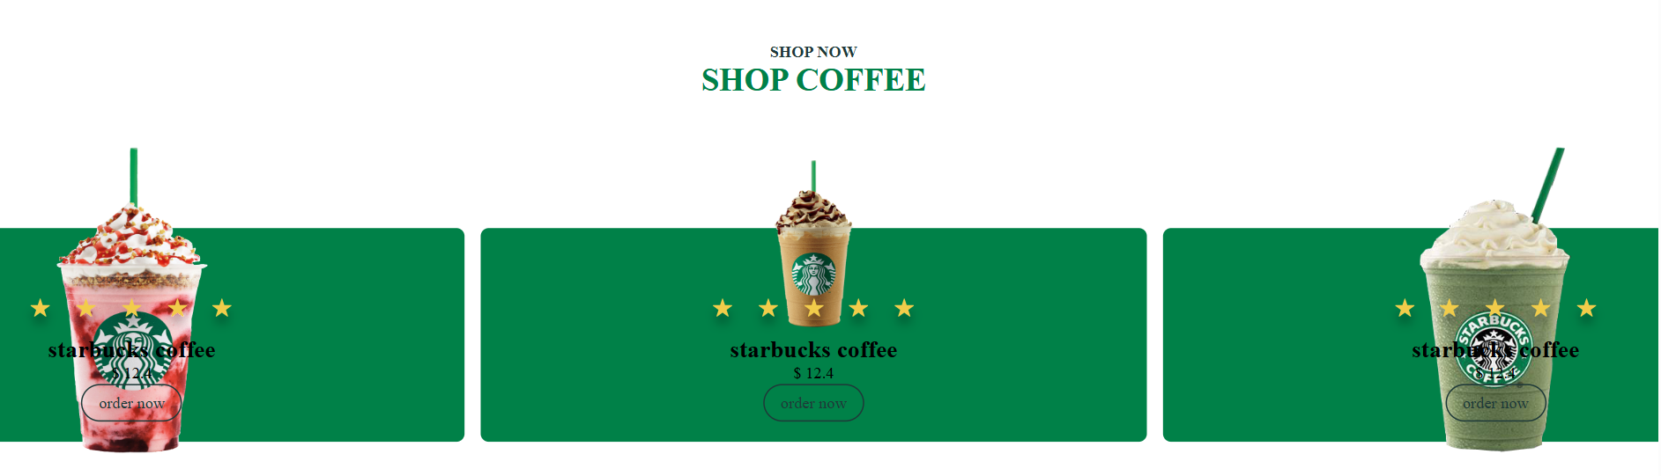

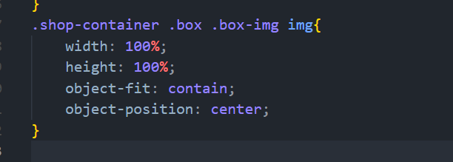

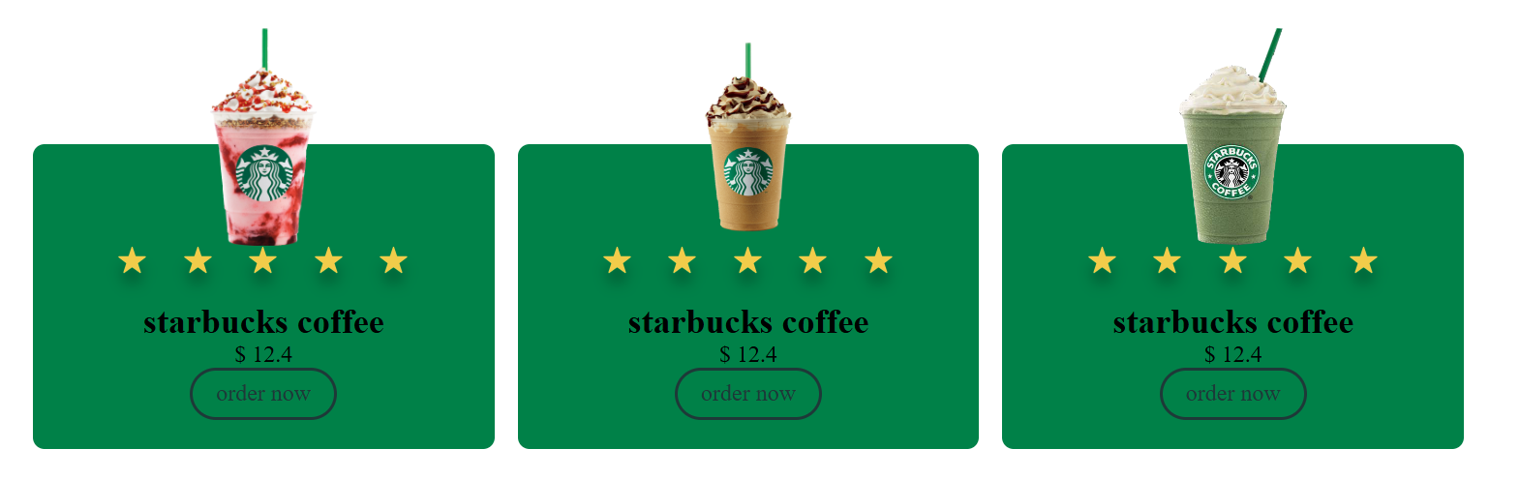

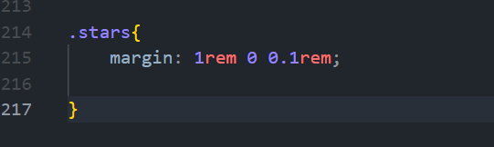

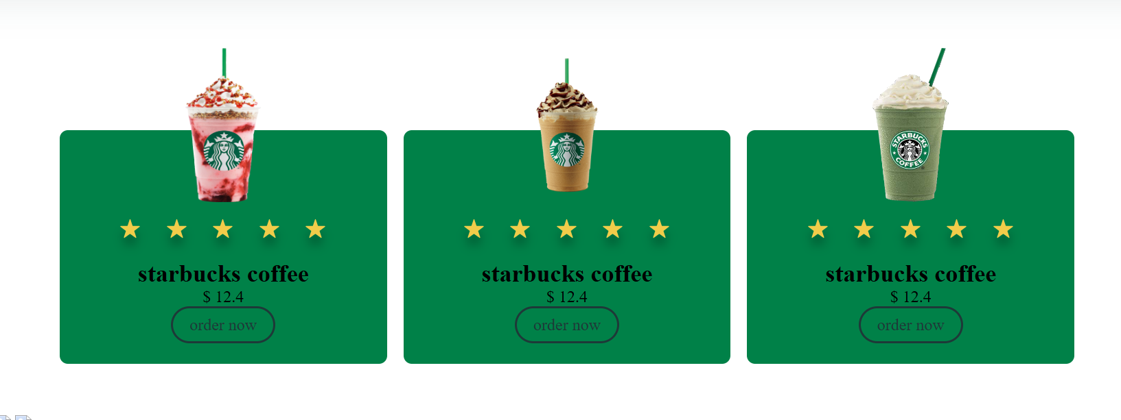

# 

Delivery

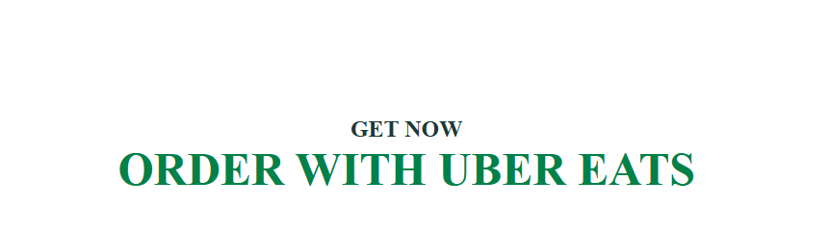

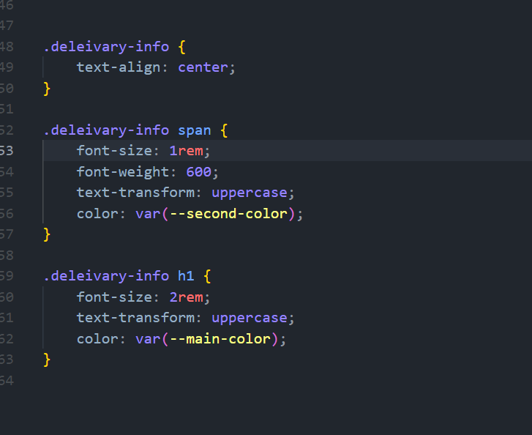

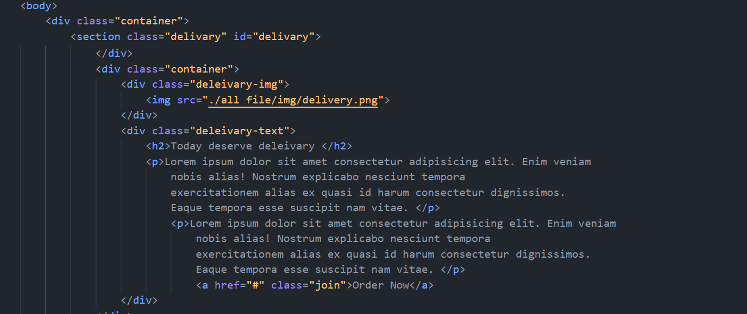

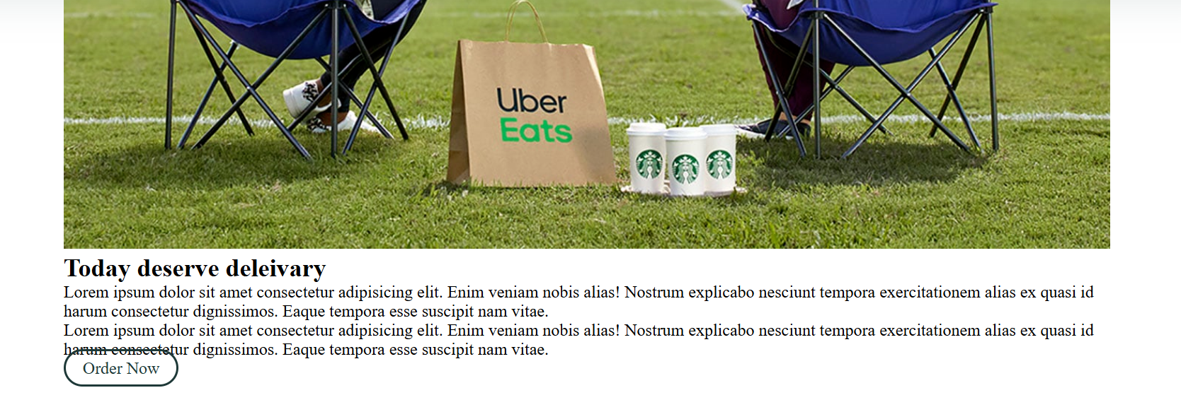

**Now do as shown bellow**

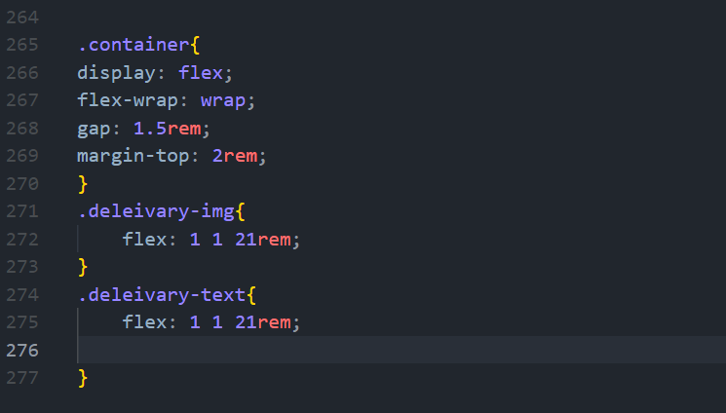

**The result as shown**

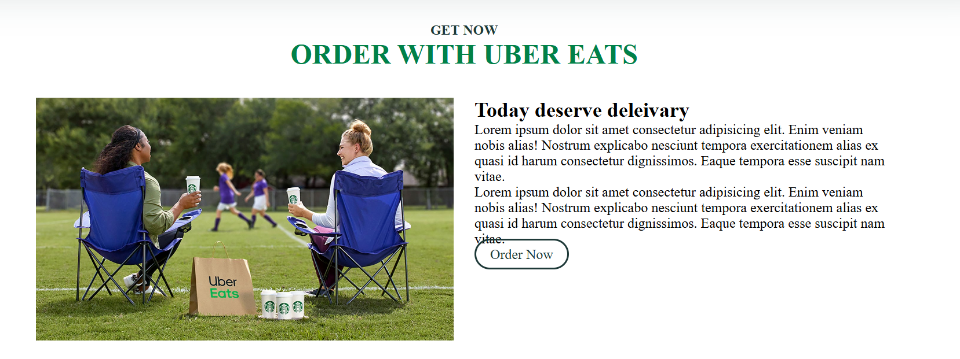

**Design p & h2**

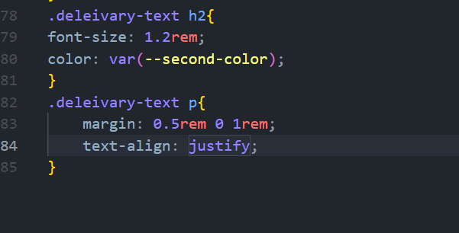

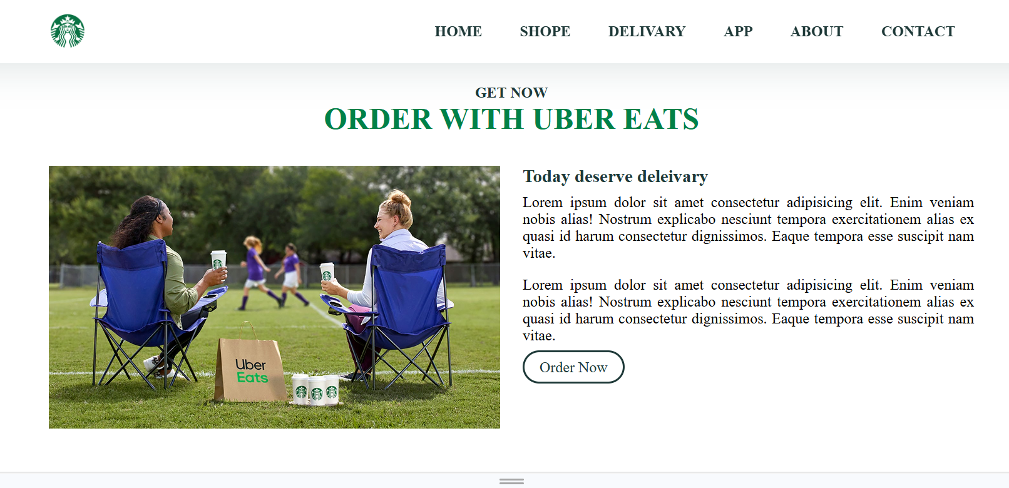

# App

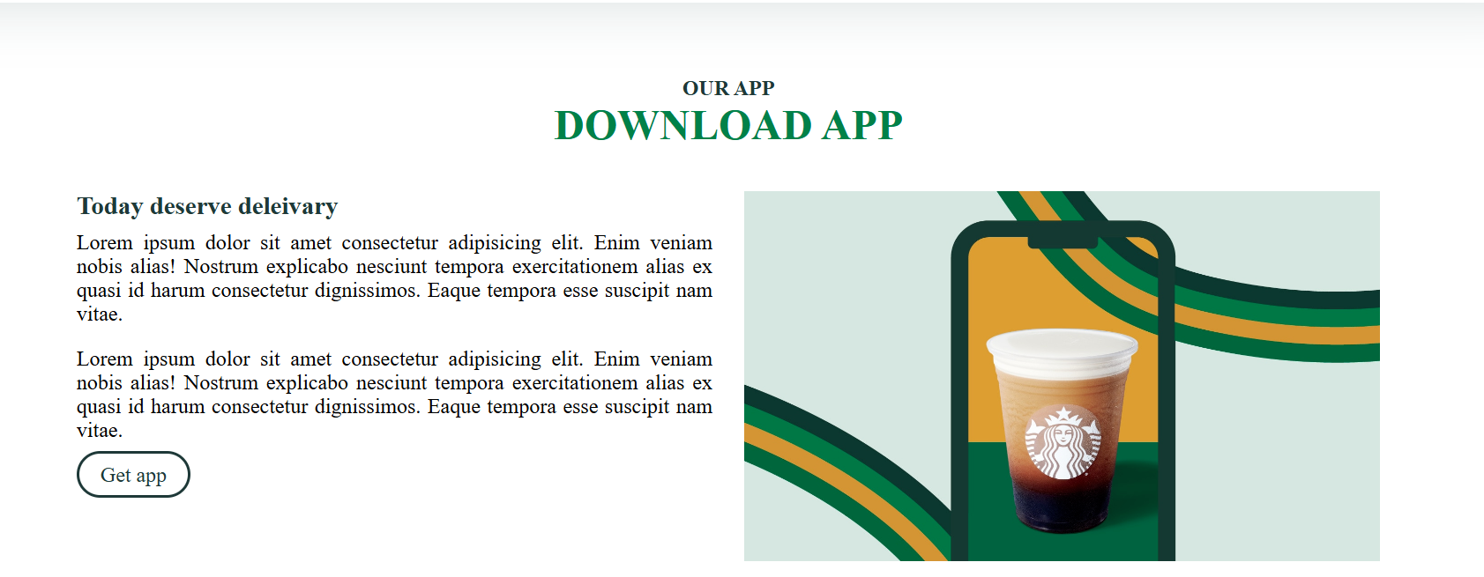

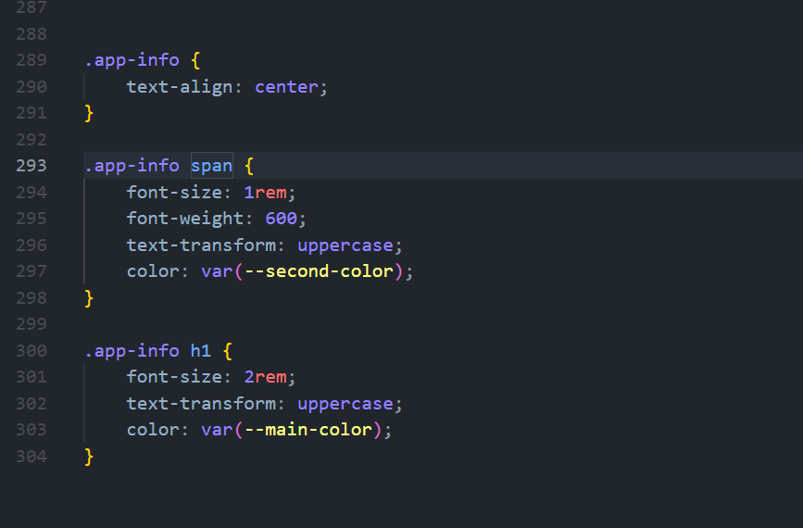

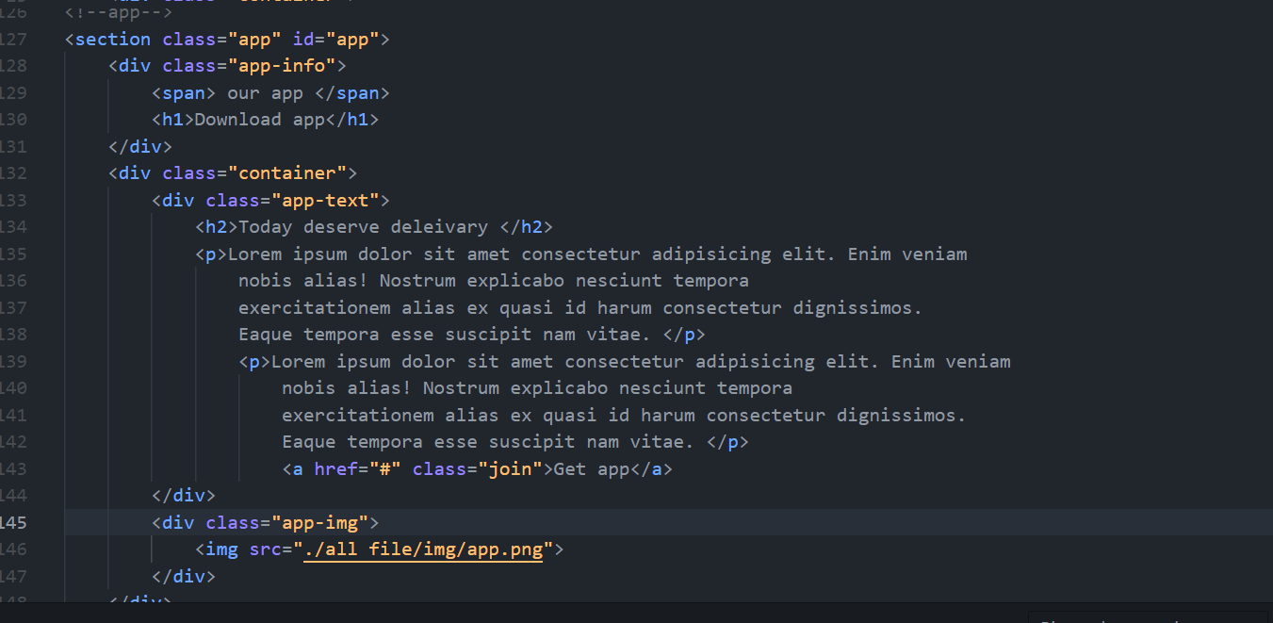

# Dib of About

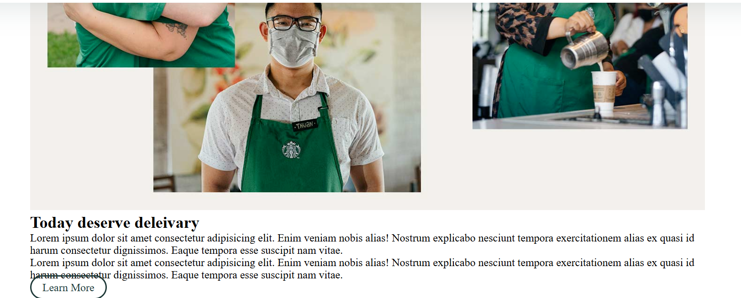

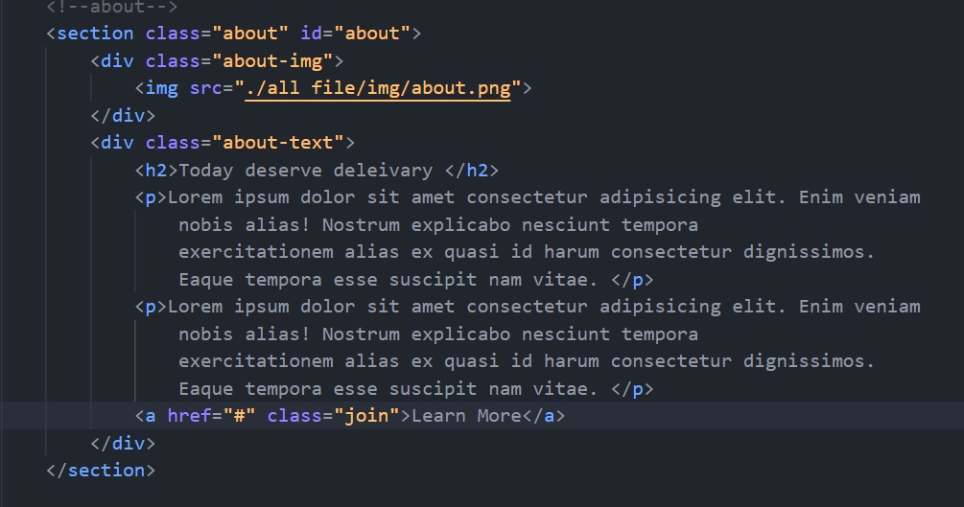

# Css of about

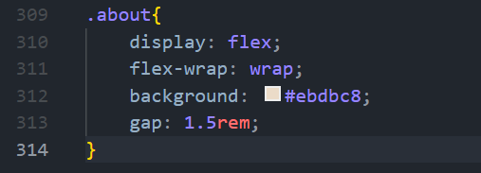

Result after do above

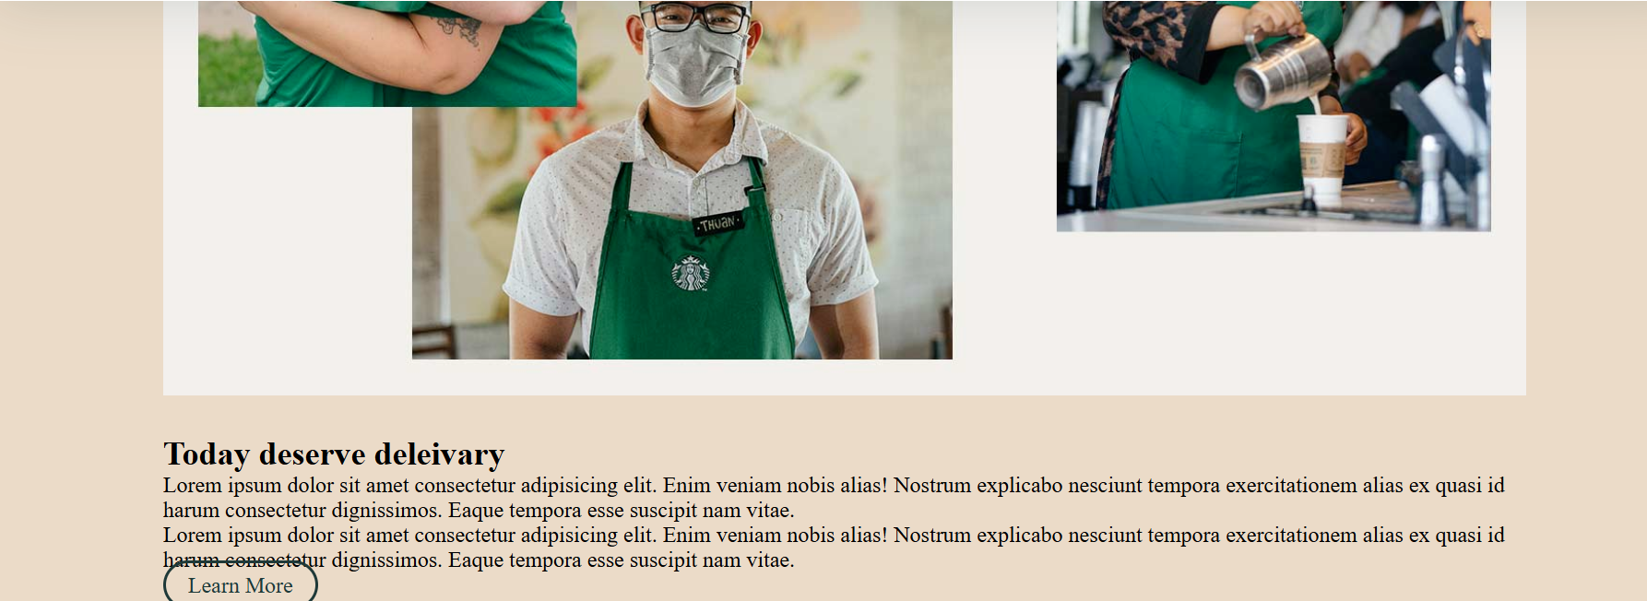

# Use flex: 1 1 17rem;

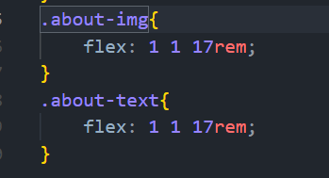

**The result as shown bellow**

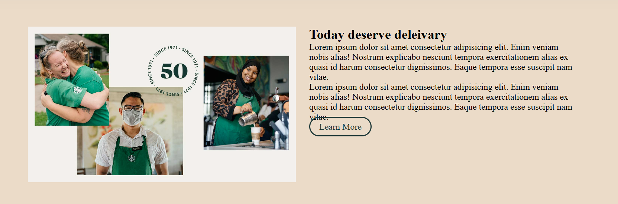

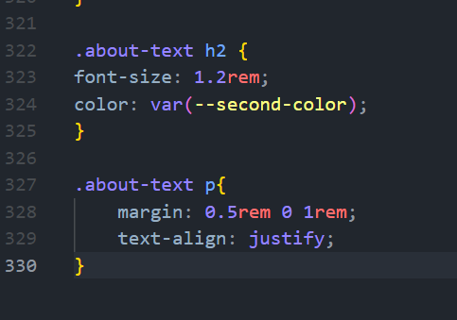

**The result after use above as shown** 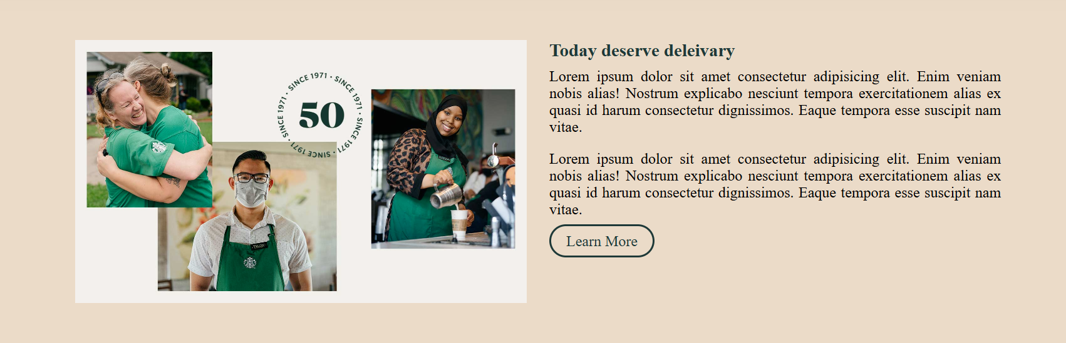

# **Div contact**

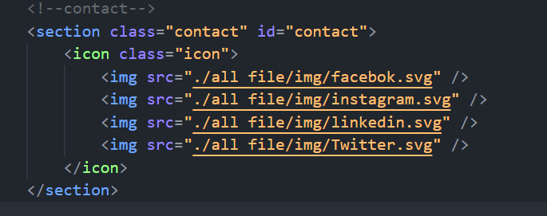

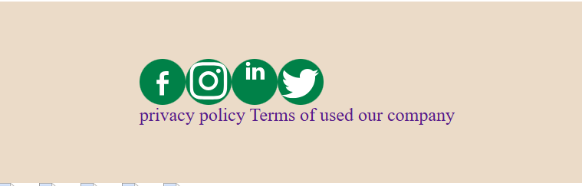

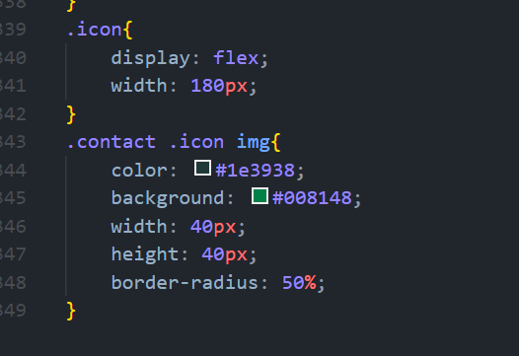

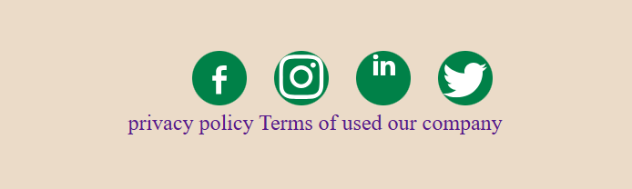

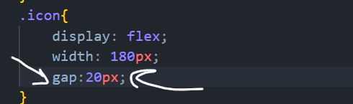

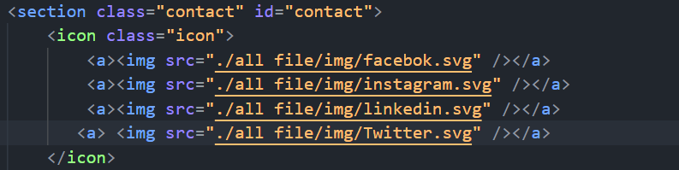

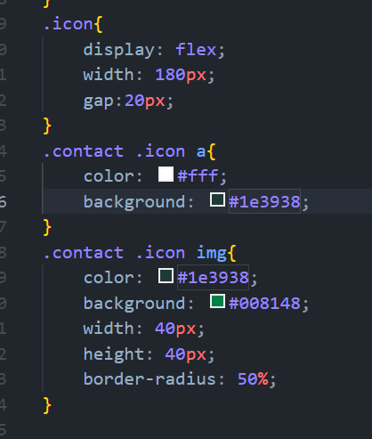

**Result as shown bellow**



**When use border radius :50%;**



# **Use img: hover**

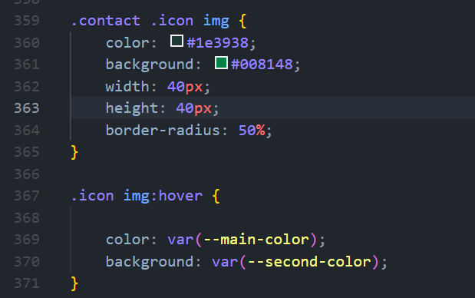

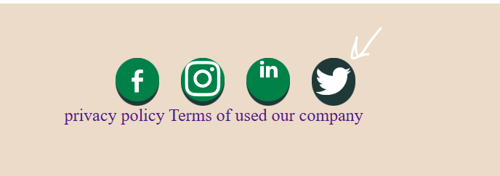

# **Link in contact**

